Job Description:
Administrator

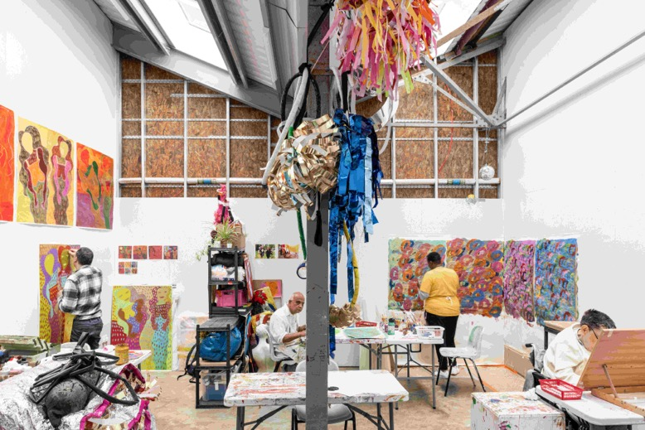

ActionSpace is looking for an exceptional individual to join our dynamic team at an exciting moment in our development. The post holder will be responsible for providing core administrative support, reporting across facilities and logistics management, with a particular focus on financial administration and internal and external communication. You will be a pro-active problem solver with a flexible approach and willingness to support different areas of the charity. In this role, the appointee will work closely with the CEO, Deputy Director and wider team to support the organisation.

ActionSpace artist Nnena Kalu winning the 2025 Turner Prize makes this an exciting time to join ActionSpace. We are looking for an individual who shares our passion for supporting learning disabled people to reach their potential and has the experience and skills to help us.

About ActionSpace

ActionSpace breaks down the barriers that prevent learning disabled people from taking part in arts and culture. We work with learning disabled young people and adults across London, providing access to studio facilities, art materials and equipment, creative mentoring and the support they need to develop and grow as artists. We also provide opportunities for people to take part in innovative creative projects, workshops, events and other activities, co-developed and co-led by learning disabled artists.

We manage three supported studios at Cockpit Bloomsbury (Holborn), Studio Voltaire (Clapham) and ASC’s Ealing Road Studios (Brent). We have on-going partnerships with a range of cultural institutions including the Royal Academy of Arts, Tate, Camden Art Centre, Autograph and the British Museum.

ActionSpace is an agent for change, challenging and disrupting the cultural sector. We provide learning disabled artists with the same opportunities enjoyed by their peers; opportunities to develop their skills and capabilities, for their work to be seen and better understood, for them to gain employment and be represented in the leadership of the sector.

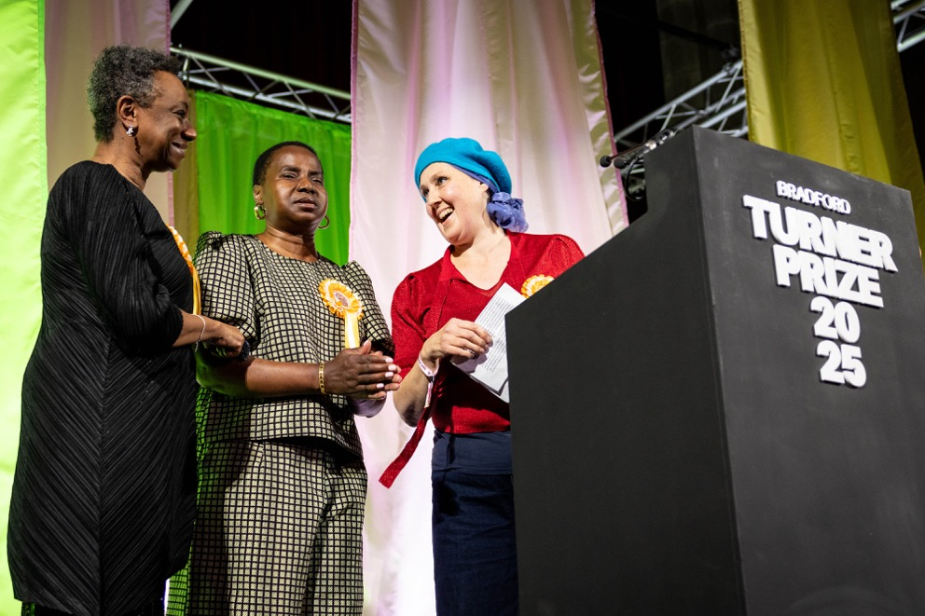
ActionSpace artist, Nnena Kalu, winning the Turner Prize 2025 - the UK’s highest accolade for visual artists - is a testament to the effectiveness of our work.

Key Responsibilities
Reporting to ActionSpace’s Deputy Director, key responsibilities of the post-holder will include the following.

Finance

Assist in the day-to-day financial administration of the charity:

- Timely financial reconciliation of accounts, budgets and cash
- Creating and processing invoices
- Administration of artwork sales
- Creating reports and supporting the Deputy Director as required

Admin / Operational

Provide core administrative support:

- Directing all incoming communications to the right person (including email, telephone, visitors and post)
- Providing administrative support for ActionSpace's learning disabled artists, with guidance from the Pastoral Care Coordinator
- Schedule meetings across the organisation and take minutes as required
- Studio/office resource management in line with our environmental policy
- Arrange the packaging and transportation of artworks
- Assisting with recruitment and new employee set up
- Keeping up to date records/filing (bank + credit card, payment confirmation letters, consent forms etc)
- Working with the Office Assistant on these tasks

Governance and Compliance

Support with maintaining up to date compliance and governance procedures:

- Schedule Board meetings and away days, and produce accurate Board minutes
- Health & Safety compliance including processing DBS checks, Safeguarding courses, and First Aid training for all relevant staff and maintain these records
- Oversee the renewal of the charity insurance policy, with support from the Deputy Director
- Adherence to Anti Money Laundering policy; training will be provided
- Record and report on all activity and audience numbers to our key partners, including Arts Council England (ACE)

Evaluation and Impact

Develop and oversee our evaluation processes:

- Develop and employ an accessible evaluation framework for our studio projects
- Produce evaluation reports in line with key stakeholder requirements
- Carry out Arts Council England evaluation surveys at key events
- Take part in training, networking and other skill development opportunities relating to inclusive evaluation practice

Other
- To be available for project support when needed
- Build contacts to expand network with peer organisations in the visual arts and public sector
- Pro-actively develop own skills, knowledge, and experience, both of our industry and best practice within it

PLEASE NOTE: In addition to the duties and responsibilities listed, the post holder is required to perform any other tasks or duties commensurate with the role, as reasonably requested by their manager from time to time.

Every member of staff is also expected to show respect to their colleagues and to understand and adhere to our standards and values; they are also expected to work in a collaborative fashion and to support all the teams with which they have contact in achieving our vision and objectives.

Person Specification

Essential | Desirable
Excellent time management skills, with the ability to manage multiple tasks and prioritise.
Excellent verbal and written communication skills, with the ability to respond quickly and appropriately by email, telephone or by letter, with a willingness to adapt communication style, including plain language and visual formats, when working with learning disabled artists
Excellent organisational, administrative and numeracy skills with high levels of accuracy, diligence and attention to detail.
Understanding of UK GDPR and confidence handling sensitive personal data, including financial records and consent forms.
Discretion and sensitivity with regards to data and communications.
Problem-solving skills and a proactive, flexible approach with a willingness to support different areas of the charity.
Positive and supportive behaviour in the workplace.
Ability to work independently and prioritise workloads, whilst also working across a range of demands on a daily basis and to deliver on time to agreed targets and deadlines.
 | An active interest in working in the cultural sector / the arts, especially contemporary visual art and art education.
 | Awareness of and an interest in current issues related to the learning disability and neurodivergent community.
 | Knowledge of the following systems: Microsoft Office, Google Suite, QuickBooks (or other accounting software), Click Up, Good CRM.
Flexibility during times of high work demand and the ability to work occasional evenings and weekends (for which time off in lieu will be given).

Contract Details

Contract: Permanent
Salary: £28,000 - £30,000 depending on experience. The role will be subject to a 3 month probationary period and regular reviews.
Hours: 35 hours per week excluding lunch break.
Reports to: Deputy Director
Reports in: Project Teams, Volunteers, Office Assistant; this role coordinates and delegates tasks across these groups.
Location: This role will be office based at our Cockpit Bloomsbury location in central London, although some travel to our studios in Clapham and Brent will be required.
Annual Leave: 25 days per annum, plus bank holidays. ActionSpace also offer an additional 3 days over the Christmas period.
Pension: ActionSpace offers an auto-enrolment pension scheme with NEST pensions
on commencement of employment, with the opportunity to opt-out.

Safeguarding
This role involves regular contact with adults who may have care and support needs, in line with the Care Act 2014. As part of our safer recruitment practice, please declare if any of the following apply to you, now or in the past:
- Any unspent criminal convictions or cautions.
- Any pending police investigation or prosecution.
- Any dismissal, resignation, or safeguarding allegation relating to your conduct towards a child or vulnerable person, whether or not formally upheld.
A disclosure won't automatically rule you out. We'll discuss it with you. Non-disclosure of something relevant may affect your appointment.
Appointment is subject to an Enhanced DBS check and references.
References and the disclosure declaration above can be completed via this form.
Other Terms
- Applicants must have the right to work in the UK.
- The postholder is expected to adhere to ActionSpace's employment policies.
- This job description is not exhaustive and duties may evolve in line with the needs of the organisation.

How To Apply

Application deadline: Monday 7th September, 10 am

Please provide a CV (maximum two A4 pages) and Cover Letter (maximum two A4 pages) addressing the criteria outlined in the Person Specification and explaining why you are interested in the post. Please also complete a references & disclosure form by clicking on the following link: References and Disclosure Form
Please email your application to: recruitment@actionspace.org quoting Administrator in the subject line.

You are welcome to contact us for an informal discussion about the role before submitting your application. Please send a request via email (including two options of a convenient call time) to recruitment@actionspace.org

Interviews online or in person are scheduled for the week beginning 14 September 2026 followed by a second interview the following week, if required.

We are committed to building a culturally diverse workforce and actively encourage submissions from applicants belonging to groups that are currently underrepresented in the arts sector in the UK: particularly people of colour, those with disabilities (including ‘invisible’ disabilities such as dyslexia or autism), and people from lower socioeconomic backgrounds.

As part of our commitment to equal opportunities, we want to make sure a wide range of people access our opportunities. Please help us by completing the form by clicking on the following link:
Diversity & Inclusion Monitoring Form

We are happy to accept applications in an alternative format such as a video presentation or audio file. If you would like support or have any queries regarding the format or submission of the application, please contact us at: info@actionspace.org

AI

We know that AI can be useful when preparing your cover letter and CV but we’d ask that you take the time to make sure that your application reflects your own voice and experiences.

