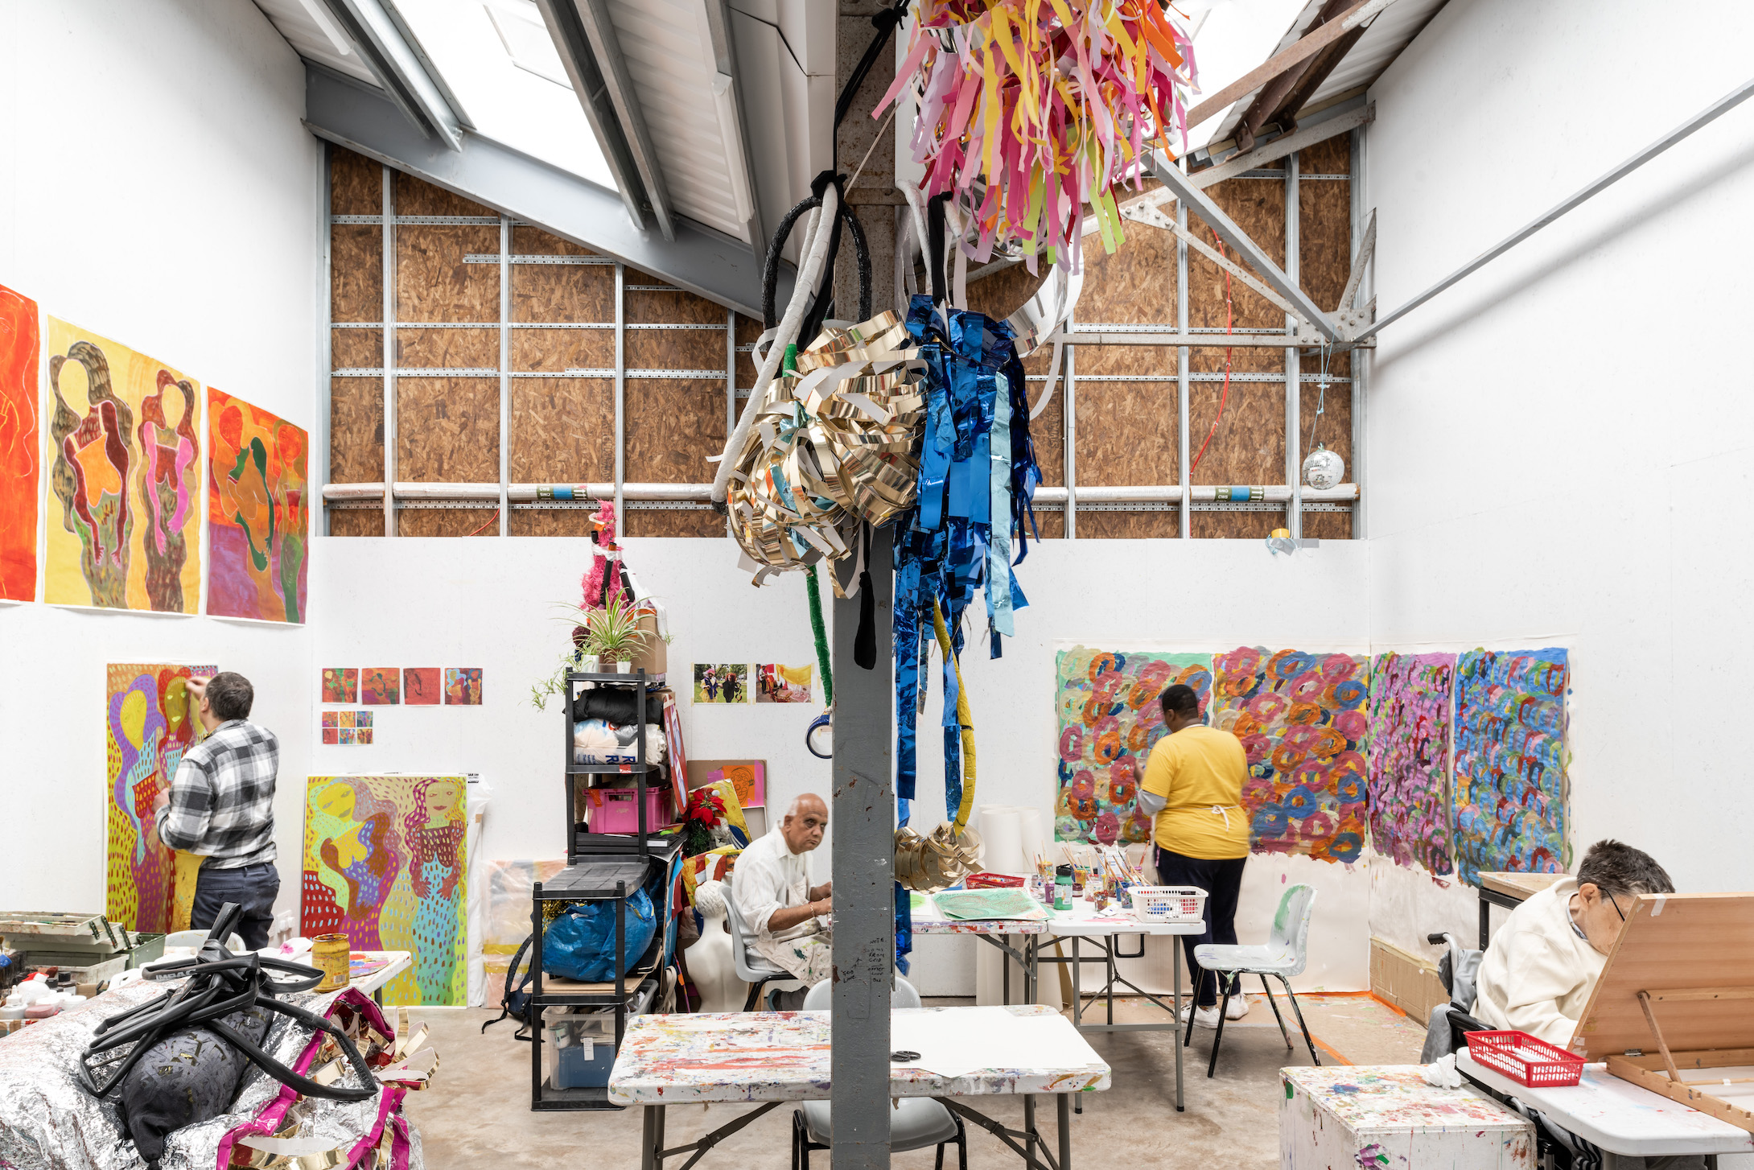
ActionSpace studio at Studio Voltaire. Credit FRENCH+TYE.

Launched in the 1960’s, ActionSpace supports learning disabled artists by providing a studio space, art materials and exhibition opportunities.

Weekly Studio Projects provide a supportive and safe environment in which our artists can explore and develop their creative talents, with guidance from a professional artist facilitator. Our artists gain a sense of their own potential, as do those around them.

Through developing a creative medium for self-expression, their self-esteem increases and their sense of isolation is reduced.

Today’s date: ___/___/_____

Personal details:

Full name:


Telephone number: ____________________________________________________________


Email:


Address
________________________________________________________________________________________________________________________
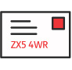
Post code


Date of Birth: ___/___/_____

Health and Access Needs:

Do you have a learning disability? Yes/No

If yes, please describe your learning disability:

________________________________________________________________________________________________________________________

Do you have a physical disability? Yes/No

If yes, please describe your physical needs:

________________________________________________________________________________________________________________________

Do you have any medical conditions? Yes/No

If yes, please write below:

________________________________________________________________________________________________________________________

Arts interests:

Are you making art at the moment? Or have you taken part in art sessions before?

If yes, where?

________________________________________________________________________________________________________________________

What type of art do you like to make? ________________________________________________________________________________________________________________________

What are your interests? Or what things do you like? ________________________________________________________________________________________________________________________

Is there anything you do not like? or anything that makes you feel upset? ____________________________________________________________
_____________________________________________________________
Contact Information:


Emergency Contact:

Name: ____________________________________________________________

Relationship to You: ____________________________________________________________
Telephone Number:
____________________________________________________________
Email: ____________________________________________________________


Home contact (e.g. a house/care manager for those not living with family):

Name: ____________________________________________________________

Job role/relationship to you: ____________________________________________________________

Telephone Number: ____________________________________________________________
Email: ____________________________________________________________

Thank you for filling in this form. Please send it back to:

Maisie Rennie-Carter
ActionSpace
Cockpit Arts
Cockpit Yard
Northington Street
London
WC1N 2NP

Or return it by email to maisie@actionspace.org

If you need any more information or have any questions about this or any other ActionSpace project, please call Maisie on 020 7209 4289 or email info@actionspace.org

For office use:

Which group/s

Trial sessions

Start date

Payment method

