Individual Giving Fundraiser: Short-Term Freelance Contract
ActionSpace is looking to engage an experienced freelance development professional to provide additional capacity and expertise in developing our individual giving programme.
Contract: | Freelance
Remuneration: | £6,000 (fixed fee/contractor solely responsible for their own tax & NI)
Timeframe: | January – May 2027 (with some flexibility)
Reporting to: | ActionSpace’s CEO / Artistic Director

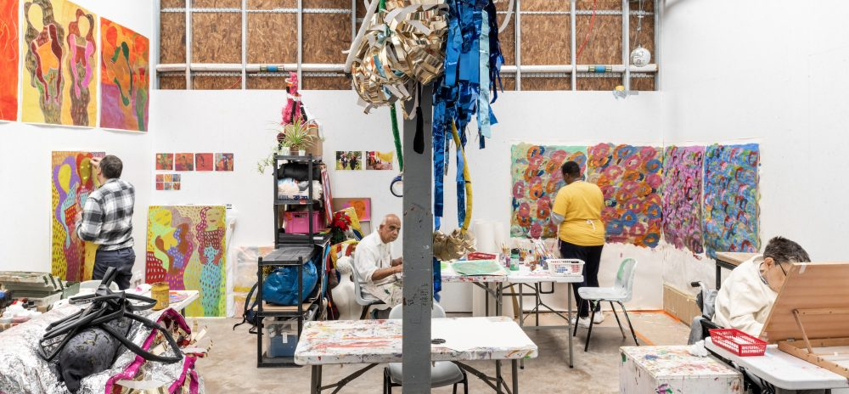
ActionSpace Studio at Studio Voltaire in South London
Photo courtesy of Studio Voltaire / Photo Credit: FRENCH+Tye

For over 40 years, ActionSpace has challenged the barriers that prevent learning disabled people from participating in arts and culture. Working from three flagship London supported studios, we support c.70 learning disabled artists on an on-going weekly basis, providing professional studio facilities and equipment, specialist support, creative opportunities and professional networks that enable them to develop and thrive. We engage with hundreds more learning disabled people each year, through our outreach projects, workshops, participatory and live art events and partnerships with leading cultural venues across London.

In December 2025, ActionSpace artist Nnena Kalu was awarded the Turner Prize, becoming the first learning disabled artist to win Britain’s most prestigious prize for contemporary visual art. This was a historic achievement, not only for Nnena but for learning disabled people everywhere. The attention generated by the Turner Prize has created an unprecedented platform for ActionSpace. We can reach new audiences, influence cultural institutions and inspire a new generation of learning disabled people.

We need the resources to build on this momentum.

The Role
We are looking to work with an experienced development professional with experience in individual giving and major gifts fundraising (ideally for arts or cultural charities) to support the launch of our new individual giving programme in the first half of 2027.

We are looking for someone with the skills and expertise to help guide and support our active work to engage and cultivate a new cohort of individual supporters. You will undertake this work with the support of our small in-house team, including our Communications and Development Officer and guided by our Head of Development (interim) and CEO / Artistic Director.

We have undertaken detailed planning / scoping in preparation for this work, including investment in a new website and CRM database. You will have the support of a newly convened advisory committee of our Board of Trustees to assist with identifying supporter prospects.

This is a hands-on role, working with the Communications and Development Officer on identification, cultivation and engagement of donor prospects. Once the contract is completed this will be handed over to the Communications and Development Officer to continue, under the supervision of our Head of Development (Interim).

Experience
- Recent, relevant experience in individual giving fundraising, ideally for an arts or cultural charity.
- Experience in engaging, cultivating and stewarding donors and HNW individuals.
- Experience in soliciting individual gifts in the £1,000 - £5,000 range.
- Experience in planning and implementing small cultivation events.
- Experience in overseeing processes for thanking, crediting and reporting to supporters.

Skills
- Ability to engage and enthuse donors and donor prospects in the work of ActionSpace.
- Willingness to work collaboratively with the ActionSpace team in an embedded way.
- Willingness to advise (and share knowledge with) the ActionSpace team and coach the Communications and Development Officer.
- Willingness to attend on-site cultivation activities at ActionSpace’s London supported studios and at other identified venues / places.

To Apply
Please send a CV and a supporting statement (up to 2 pages) outlining your experience and how you would propose delivering the role within the timeframe and fee (indicating your anticipated breakdown of days / your daily rate).

Deadline for applications: Wednesday 11 November 2026, 10am
Interviews: Tuesday 17 November 2026

Please email your application to: Sheryll@actionspace.org quoting “Individual Giving Fundraiser” in the subject line.

If you would like to arrange a conversation ahead of applying, please email us at Sheryll@actionspace.org

